# Day 1 - Deploy the Sync Server

**Deploy the VM.** Azure portal > **Virtual machines > Create > Azure virtual machine**
Basics tab
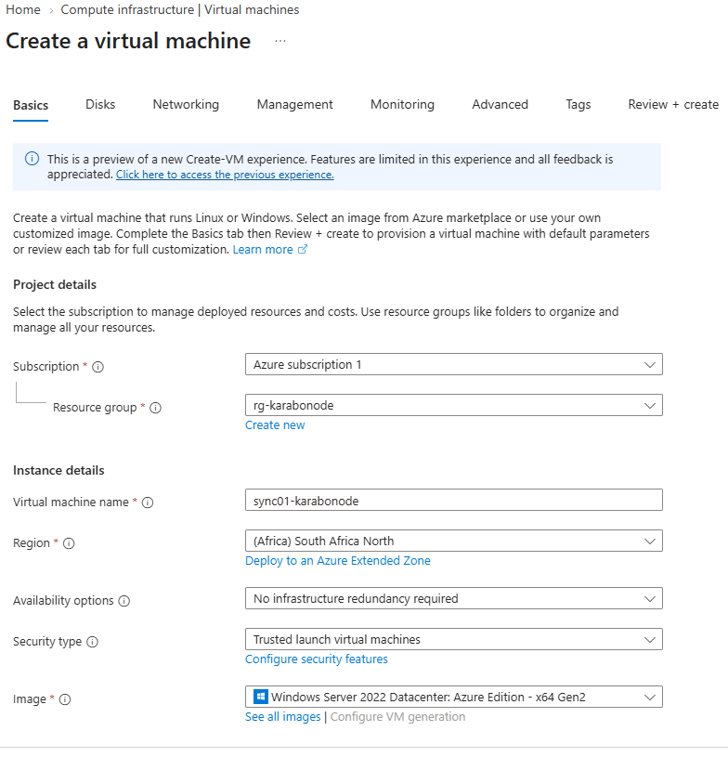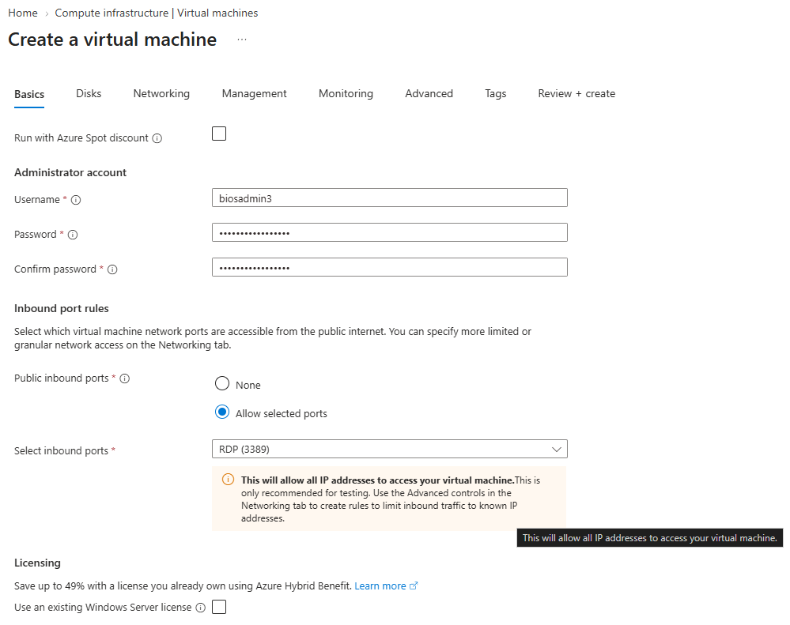
Networking Tab
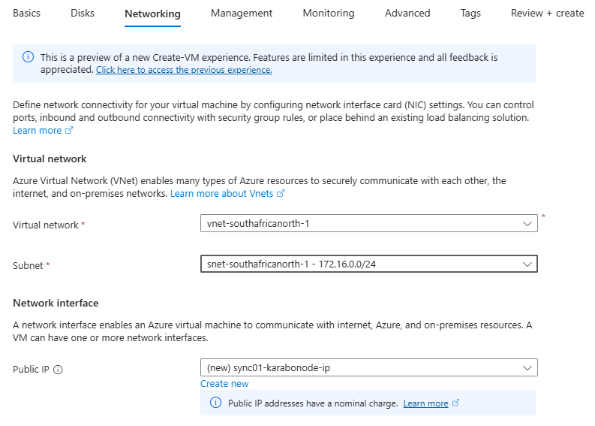
Review + Create
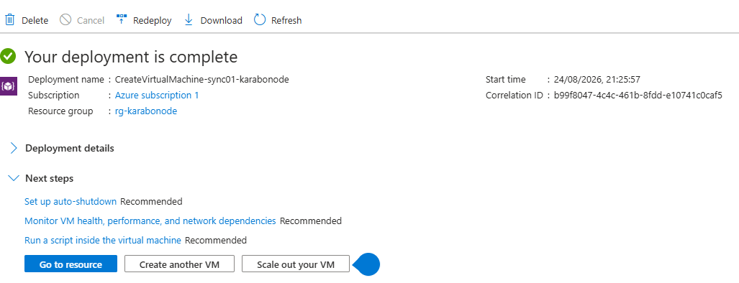
Lock down the NSG
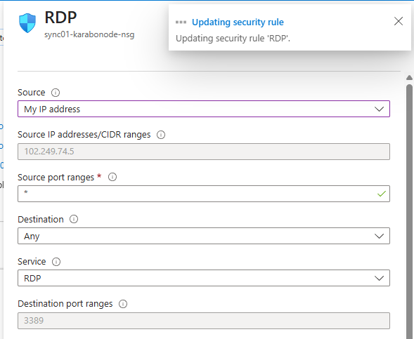
Point DNS at the DC, then join the domain.
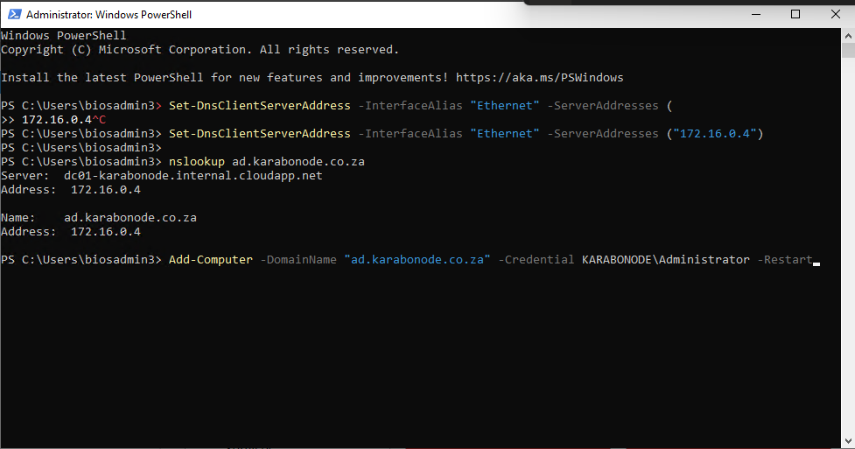
1. Set the DNS server
Set-DnsClientServerAddress -InterfaceAlias "Ethernet" -ServerAddresses ("172.16.0.4")
What it does:
Changes the DNS server configuration of the server's Ethernet network adapter to 172.16.0.4, which is DC01's private IP address.
Why?
Active Directory relies heavily on DNS. The member server needs to ask DC01's DNS service where ad.karabonode.co.za and the domain controllers are located.
Summary:
"Use DC01 as my DNS server."

2. Test DNS resolution
nslookup ad.karabonode.co.za
What it does:
Queries DNS to find the IP address associated with ad.karabonode.co.za.
You should get a response pointing to your domain controller/DNS server.
Why?
Before attempting the domain join, you want to confirm that the member server can actually find the AD domain through DNS.
Summary:
"Can I find my Active Directory domain through DNS?"
If this fails, fix DNS first rather than trying the domain join.

3. Join the computer to the domain
Add-Computer -DomainName "ad.karabonode.co.za" -Credential KARABONODE\Administrator -Restart
What it does:
Adds the current Windows Server to the ad.karabonode.co.za Active Directory domain.
Let's break it down:
- Add-Computer → joins a computer to a domain or workgroup.
- -DomainName "ad.karabonode.co.za" → specifies the AD domain.
- -Credential KARABONODE\Administrator → tells Windows which domain account has permission to join the computer.
- -Restart → automatically restarts the server after the successful domain join.
You'll be prompted for the Administrator password.
Summary:
"Join this server to my AD domain using a domain account, then restart."

After the reboot, log in as `KARABONODE\Administrator`
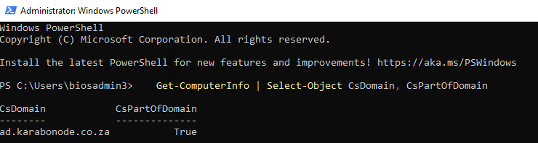
`CsPartOfDomain` should be `True`. This is a **member server** — it belongs to the domain but holds no copy of the AD database, which is exactly the separation Entra Connect requires

Why this matters
Entra Connect must never run on a domain controller in real deployments.

Skills covered
Member-server deployment and domain join (`Add-Computer`), the DC vs. member server distinction, the sync-server placement rule real hybrid deployments follow.

